**COMS3200 - ASSIGNMENT 2 (PART A)**

**Jiefeng Hou**

**43034002**

Q1

Frame = 800 bytes = 800 * 8 bits = 6400 bits

Data rate = 10Mbps = 10000000 bits/s = 1*107 bits/s

Propagation delay = 5 μsec/km for 5 km = 5*5 μsec = 25 μsec = 0.025 ms

3 bits allocated for 8 (23 = 8) sequence number = 0 -> 7 (23 - 1 = 7). And because of selective repeat protocol (SWS <= (MaxSeqNum+1)/2, so SWS = 4 = (7+1)/2), only 4 sequence numbers can be used at once (0 -> 3), so 4 packets in transit at once.

It takes Frame/Data rate = 6400/10000000 = 0.00064 s = 0.64 ms to send one frame. After sending the last bit of the frame, it takes 25 μsec to receiver who response with ACK taking another 25 μsec. Therefore, the ACK for any given packet is received 50 μsec after sending the packet. It means that if the sequence number needs to be reused more than 50 μsec after using it send a packet, the sender will not have to wait for it to be free.

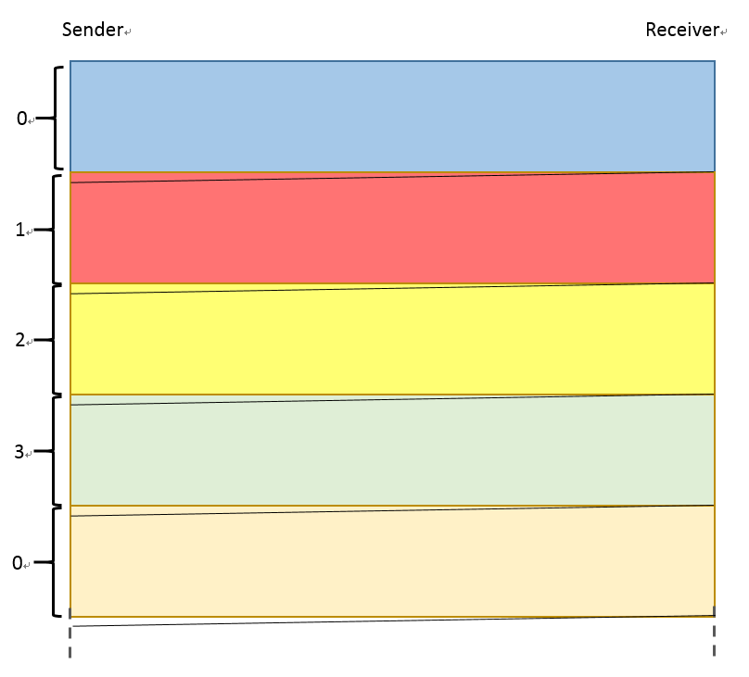

By the time the sender is ready to send a packet using sequence number ‘0’, the ‘0’ is available to use (the ACK for it was received shortly after starting to send packet 1), so the sender does not have to wait at all, it can continually send.

So T1 (transmission time of 4 packets): 4 * 0.64ms = 2.56ms, and T2 (total propagation time is the transmission time for the frame and reply frame plus the propagation time): 0.025ms + 0.64ms + 0.025ms + 0.64ms = 1.33ms. Because T1 > T2, so maximum utilization is = 100%.

Q2

Frame = 800 bytes = 800 * 8 bits = 6400 bits

Data rate = 10Mbps = 10000000 bits/s = 1*107 bits/s

Propagation delay = 5 μsec/km for 100 km = 5*100 μsec = 500 μsec = 0.5 ms

3 bits allocated for 8 (23 = 8) sequence number = 0 -> 7 (23 - 1 = 7). And because of Go-back-n protocol (SWS <= MaxSeqNum, so SWS = 7), only 7 sequence numbers (0->7 except one) can be used at once, so 7 packets in transit at once.

It takes Frame/Data rate = 6400/10000000 = 0.00064 s = 0.64 ms to send one frame, so it takes 7 * 0.64 ms = 4.48 ms to send 7 packets. The following segment repeats with strings of 7 frames with consecutive sequence numbers (0123456, 7012345, 6701234, 5670123, 4567012, 3456701, 2345670, 1234567, etc.) with same timing.

So T1 (transmission time of 7 packets): 7 * 0.64ms = 4.48ms, and T2 (total propagation time is the transmission time for the frame and reply frame plus the propagation time): 0.5ms + 0.64ms + 0.5ms + 0.64ms = 2.28ms. Because T1 > T2, so maximum utilization is = 100%.

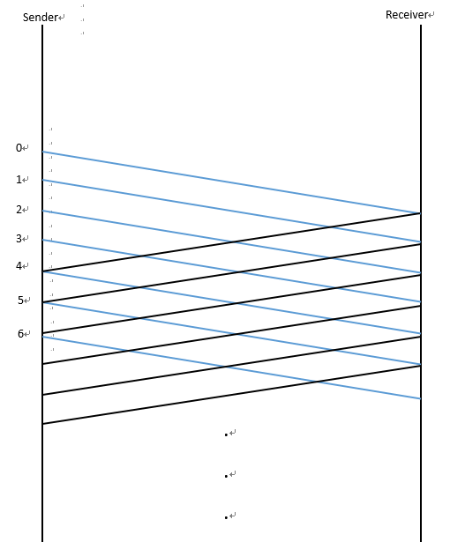

Q3

(1)

Frame = 800 bytes = 800 * 8 bits = 6400 bits

Data rate = 10Mbps = 10000000 bits/s = 1*107 bits/s

Propagation delay = 5 μsec/km for 5 km = 5*5 μsec = 25 μsec = 0.025 ms

7 bits allocated for 128 (27 = 128) sequence number = 0 -> 127 (27 - 1 = 127). And because of selective repeat protocol (SWS <= (MaxSeqNum+1)/2, so SWS = 64 = (127+1)/2), only 64 sequence numbers can be used at once (0 -> 63), so 64 packets in transit at once.

It takes Frame/Data rate = 6400/10000000 = 0.00064 s = 0.64 ms to send one frame. After sending the last bit of the frame, it takes 25 μsec to receiver who response with ACK taking another 25 μsec. Therefore, the ACK for any given packet is received 50 μsec after sending the packet. It means that if the sequence number needs to be reused more than 50 μsec after using it send a packet, the sender will not have to wait for it to be free.

By the time the sender is ready to send a packet using sequence number ‘0’, the ‘0’ is available to use (the ACK for it was received shortly after starting to send packet 1), so the sender does not have to wait at all, it can continually send. In addition, the performance is exactly 100%, as the sender is constantly sending data.

So T1 (transmission time of 64 packets): 64 * 0.64ms = 40.96ms, and T2 (total propagation time is the transmission time for the frame and reply frame plus the propagation time): 0.025ms + 0.64ms + 0.025ms + 0.64ms = 1.33ms. Because T1 > T2, so maximum utilization is = 100%.

(2)

Frame = 800 bytes = 800 * 8 bits = 6400 bits

Data rate = 10Mbps = 10000000 bits/s = 1*107 bits/s

Propagation delay = 5 μsec/km for 100 km = 5*100 μsec = 500 μsec = 0.5 ms

7 bits allocated for 128 (27 = 128) sequence number = 0 -> 127 (27 - 1 = 127). And because of Go-back-n protocol (SWS <= MaxSeqNum, so SWS = 127), only 127 sequence numbers (0->127 except one) can be used at once, so 127 packets in transit at once.

It takes Frame/Data rate = 6400/10000000 = 0.00064 s = 0.64 ms to send one frame, so it takes 127 * 0.64 ms = 81.28 ms to send 127 packets. The following segment repeats with strings of 127 frames with consecutive sequence numbers (0123…126, 1270123…125, etc.) with same timing.

So T1 (transmission time of 127 packets): 127 * 0.64ms = 81.28ms, and T2 (total propagation time is the transmission time for the frame and reply frame plus the propagation time): 0.5ms + 0.64ms + 0.5ms + 0.64ms = 2.28ms. Because T1 > T2, so maximum utilization is = 100%.

Q4

|  |  |  |  |  |  |
| --- | --- | --- | --- | --- | --- |
| **Source MAC address** | **Dest. MAC address** | **Source IP address (or host)** | **Dest. IP address (or host)** | **Protocol(s)** | **Contents** |
| m2 | * (Broadcast) | Not Applicable | Not Applicable | ARP | Who owns 134.56.6.1? |
| m2 | m3 | B | ns | DNS / UDP / IP | What’s the IP address for  Server1.dept.org.com? |
| m6 | m4 | ns | B | DNS / UDP / IP | IP address is 134.73.1.5 |
| m2 | m3 | B | Server 1 | TCP/IP | SYN |
| m5 | m4 | Server 1 | B | TCP/IP | SYN/ACK |
| m2 | m3 | B | Server 1 | TCP/IP | ACK |
| m2 | m3 | B | Server 1 | TCP/IP | Message |
| m3 | m2 | Server 1 | B | TCP/IP | ACK |
| m5 | m4 | Server 1 | B | TCP/IP | Response |
| m4 | m5 | B | Server 1 | TCP/IP | ACK |
| m2 | m3 | B | Server 1 | TCP/IP | FIN |
| m5 | m4 | Server 1 | B | TCP/IP | FIN/ACK |
| m2 | m3 | B | Server 1 | TCP/IP | ACK |